# **TN Marginal Workers Assessment**

**Project : 03**

**Project Definition:**

This project focuses on analyzing the demographic characteristics of marginal workers in Tamil Nadu. Marginal workers are those who, due to the nature of their employment, have limited access to stable employment and often face socioeconomic challenges. Understanding their demographic distribution and characteristics is crucial for policy-making and addressing socio-economic disparities.

**Project Objectives:**

* Analyzing marginal worker demographics
* Understanding age and gender distribution
* Exploring industrial categories

**Design Thinking Process:**

To effectively tackle this project, we will follow a structured approach, incorporating the principles of design thinking.

* Empathize:

Gain a deep understanding of the problem statement and the context of marginal workers in Tamil Nadu.

Collect relevant data sources and information about the demographic characteristics, employment patterns, and living conditions of marginal workers.

Interview key stakeholders, including government agencies, non-governmental organizations, and the workers themselves, to gain insights into the challenges they face.

* Define:

Clearly define the scope of the project, specifying what will be included and excluded from the analysis.

Identify the target audience for the analysis, which may include policymakers, researchers, and organizations working with marginal workers.

Develop a list of research questions that the analysis should answer, such as:

What is the age distribution of marginal workers in Tamil Nadu?

How are marginal workers distributed across different industrial categories?

What is the gender distribution among marginal workers?

* Ideate:

Explore potential data sources for the analysis, such as census data, labor department reports, and survey data.

Consider various data visualization techniques to represent demographic characteristics effectively.

Brainstorm ideas for visualizations and data analysis approaches.

* Prototype:

Choose the appropriate data analysis tools and libraries for the project. Python, along with libraries like Pandas, Matplotlib, and Seaborn, is a suitable choice.

Develop a data pipeline for data extraction, cleaning, and transformation.

Create prototype visualizations to test different visualization types, such as bar charts, pie charts, heatmaps, and geographical maps.

* Test:

Review and validate the prototype visualizations with a small sample of the data.

Gather feedback from project stakeholders and make necessary adjustments to the visualizations.

Ensure that the visualizations effectively communicate the demographic characteristics of marginal workers

* Implement:

Scale up the data analysis and visualization process to handle the entire dataset.

Automate data retrieval and processing as much as possible to ensure efficiency.

Implement the final visualizations and analysis.

* Iterate:

Continuously refine the visualizations and analysis based on feedback and changing requirements . Stay open to adjustments and improvements throughout the project.

**Visualization Selection:**

## **Bar Graphs**

Bar graphs are used show the distribution of qualitative (categorical) data.It shows the **frequency** of values in the data. Frequency is the amount of times that value appeared in the data.

Each category is represented with a bar. The height of the bar represents the frequency of values from that category in the data.

## **Pie Charts**

Pie graphs are used to show the distribution of qualitative (categorical) data .It shows the **frequency** or **relative frequency** of values in the data .Frequency is the amount of times that value appeared in the data. Relative frequency is the percentage of the total. Each category is represented with a slice in the 'pie' (circle). The size of each slice represents the frequency of values from that category in the data.

## **Heat Map**

A heat map is a two-dimensional representation of data in which various values are represented by colors. A simple heat map provides an immediate visual summary of information across two axes, allowing users to quickly grasp the most important or relevant datapoints. More elaborate heat maps allow the viewer to understand complex datasets.

A heat map is a way to represent data points in a data set in a visual manner. All heat maps share one thing in common -- they use different colors or different shades of the same color to represent different values and to communicate the relationships that may exist between the variables plotted on the x-axis and y-axis. Usually, a darker color or shade represents a higher or greater quantity of the value being represented in the heat map.

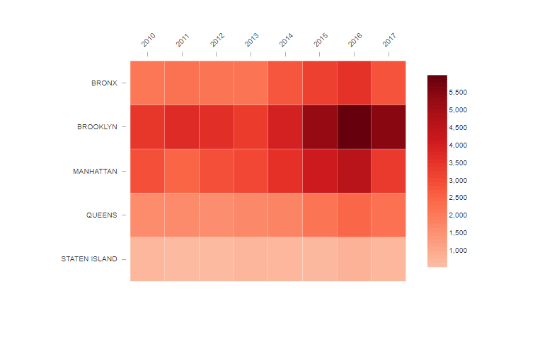

**Conclusion:**

In this phase, we have defined the problem, objectives, and outlined the design thinking process for the project. The next steps involve data collection, data analysis, and visualization, which will be detailed in subsequent project phases. The ultimate goal is to provide meaningful insights that can inform policies and initiatives aimed at improving the lives of marginal workers in Tamil Nadu.